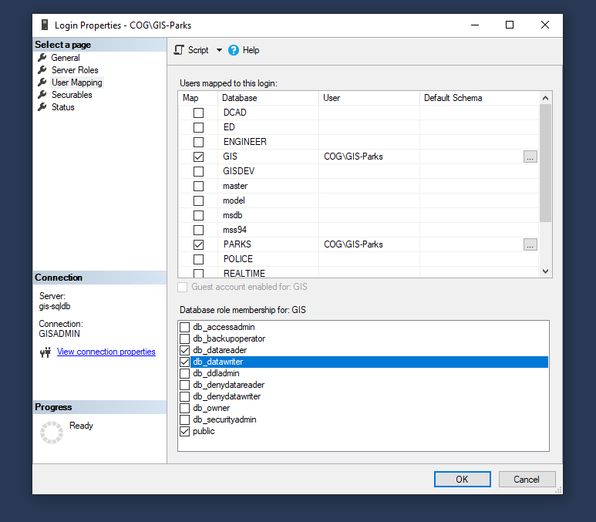

How to control uses/ roles in SQL db.

Db_datawritter, db-datareader.

Db-owner == can delete and add tables.